Project 1

Baibin Hong u3185388

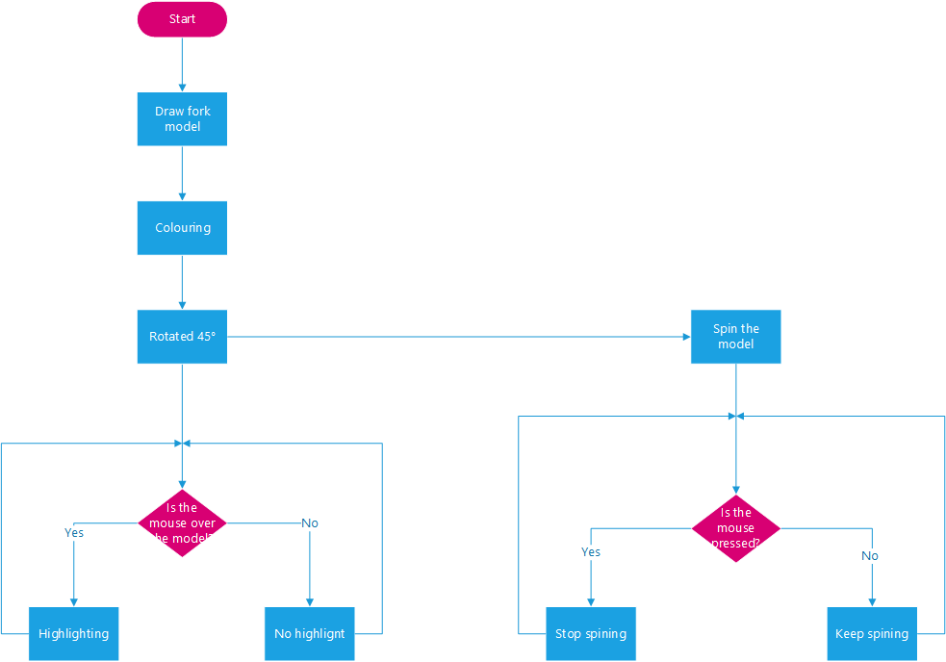

This is a project which is combining a fork model by several types of objects.

Delete the strokes, rotate the entire object to 45 degrees; The handle and blades are filled with gold and silver colours.

The whole object is spinning. When the mouse is in any location of the object, this area will be highlighted; if the mouse has been pressed, the fork will stop in the origin statue.

Html file (Project 1 u3185388.html):

<html>

<head>

<script src="https://cdnjs.cloudflare.com/ajax/libs/p5.js/0.9.0/p5.js"></script>

<script src="P5.js"></script>

</head>

<body>

</body>

</html>

JavaScript file (P5.js):

function setup() {

createCanvas(1024,1000,WEBGL);

}

function draw() {

let locX = mouseX - height / 2;

let locY = mouseY - width / 2;

background(125);

if (mouseIsPressed) {

rotateZ(frameCount \* 0.00);

rotateY(frameCount \* 0.00);

}else{

rotateZ(frameCount \* 0.01);

rotateY(frameCount \* 0.01);

}

rotateZ(45);

ambientLight(50);

directionalLight(212, 175, 55, 0.25, 0.25, 0);

pointLight(255, 223, 0, locX, locY, 0);

ambientMaterial(212);

noStroke();

translate(0,400);

sphere(45);

translate(0,-87);

cylinder(23,200);

ambientLight(50);

directionalLight(169, 169, 169, 0.25, 0.25, 0);

pointLight(211, 211, 211, locX, locY, 0);

ambientMaterial(169);

translate(0,-400);

cone(32,-610);

translate(0,315);

box(260,21,65);

translate(100,-206);

cone(20,-400);

translate(-195,0);

cone(20,-400);

}

Pseudo-Code:

Function setup() {

Creating a 1024\*1000 type of canvas with WEBGL.

}

Function draw() {

Let the mouse local X, Y be 2 pixels.

Set background colour is gray(125);

If (the mouse is pressed in the canvas.) {

Stop rotating;

}else{

Keep rotating the whole object from X, Y-axis by particular speed (frame count times 0.01);

}

Rotate the whole object to 45 degree from Z-axis;

Set ambient light range is 50 pixels;

Set the whole object light is gold (212,175,55);

Highlight the gold area (255,223,0) when the mouse is set;

Set the ambient material is gold (212);

Delete the lines in all of the objects;

Move the object (the sphere in the next) to 400 Y-axis;

Create a sphere with 45 radium;

Move the object (the cone in the next) to -87 Y-axis which is centred on the sphere;

Create a cylinder with 23 radium and 200 height;

Set ambient light range is 50 pixels;

Set the object (3 cones and a box) light is silver (169,169,169);

Highlight the silver area (211,211,211) when the mouse is set;

Set the ambient material is silver (169);

Move the object (the cone in the next) to -400 Y-axis which is centred on the cylinder;

Create a cone with 32 radium and 610 height;

Move the object (the box in the next) to 315 Y-axis which is centred on the last cone;

Create a box with 260 width, 21 height, 65 depth;

Move the object (the cone in the next) to 100 X-axis, -206 Y-axis which is centred on the box;

Create a cone with 20 radium, 400 height;

Move the object (the cone in the next) to -195 X-axis which is centred on the last cone;

Create a cone with 20 radium, 400 height;

}